This issue will cover several of the tools for selecting objects in Revit.

* **Selecting (and deselecting) Multiple Objects:** If you’ve used Revit you’ve probably noticed that if you select one object and then click on another the original selection goes away.  To select more than one object either click and drag to create a **Selection Box** (left-to-right selects only items completely enclosed in the box and right-to-left selects anything it crosses/touches/or completely includes) or use **Ctrl+LeftClick** to add individual items to the selection set (**Shift+Leftclick** will remove items from the selection set).
* **Dagnabbit! I just clicked and lost my selection set!** Good news! You can get it back. Holding down **Ctrl+ ←** (left keyboard arrow) will bring back your previous selection. You can also **right-click** and choose “**Select Previous**”
* **Selection Filter:** Often I find that I need to select all of a specific category of elements in a view, but I don’t want to hide everything else or try to **Ctrl+Leftclick** every individual element. Revit makes this easy by having a Selection Filter. Use a selection box to pick multiple elements. Then click on the filter icon on either the ribbon cid:image003.jpg@01CEBA0C.44D7F2A0or the bottom right corner of the screen cid:image008.jpg@01CEBA0C.44D7F2A0(the number is how many total objects are currently selected). This will open the Filter dialog box and give you a list of all the item categories selected and how many of each are selected. From here you can check the items you want to keep in your selection and/or uncheck all the categories remove from the selection set.

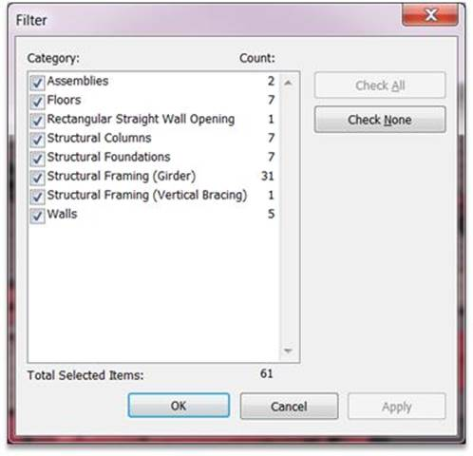

Selection Filter

* **Select All Instances:** Have you ever wanted to change all elements of one type in a view to another type, change a properties in all elements of a specific type, or quickly find out how many of a certain type are used in a project? There’s an easy way to do that. In any view **right-click** on any object. From the pop-up menu choose “Select All Instances” and then either “Visible in View” to select on instances of that type in the current view or “In Entire Project” to select all instances in the entire project. Once the instances are selected, any properties can be changed and by checking the bottom right corner of the screen you can find out the total count.
* **How do I select an element that is near so many other elements?** Maybe it’s a floor edge or there’s just a whole bunch of stuff in the same place, but every now and then there’s something that just doesn’t want to be selected. This is where **Hover-Tab-LEFTClick** is really useful. To do this **HOVER** your mouse over the object you want to select, without moving your mouse press **tab** to cycle through all objects until the object you want is highlighted (or check the status bar cid:image011.jpg@01CEBA0C.44D7F2A0 in the lower left corner for the object name you are looking for to show up), and **Leftclick** to select the object.

**Hover-Tab-Click** can also be used to cycle between faces of walls (when trying to extend or align objects) or to cycle through selection of a single object or a string of them (walls, beams, lines, etc).

As always, if you want more information on any Revit topic, have discovered a better way of doing things, have a Revit question, or have a “Tips and Tricks” request don’t hesitate to contact Katie Chapman.